# Sternberg

# Introduction

According to stage theory, cognitive processing progress in separate stages (Sternberg, 1969). This provides the theoretical ground for Sternberg’s (1969) memory recognition task as he argues that encoding and comparison of test stimuli to representations held in memory are discrete processes (Sternberg, 1969). This experiment follow the paradigm used by Sternberg (1969).

Memory search may be parallel or serial, self-terminating or exhaustive (Radvansky & Ashcraft, 2014).

According to Sternberg (1969), in serial search, reaction time (RT) would increase as memory set size increases, and for a serial exhaustive search RT slopes for present and absent probes would be parallel.

Sternberg (1969) also debates that degradation of stimuli might lead to a longer encoding stage, reflecting an “unmasking” (resulting in an increased zero-intercept), or a longer comparison stage (resulting in a steeper RT slope).

Sternberg (1969) found that participants performed serial exhaustive search in the present tasks, and that degradation of stimuli influenced the encoding stage. The results of the present experiment are expected to agree with this.

# Method

The experiment included *N* = 194 participants, all psychology students at UCPH. Age and gender differences were not considered.

## Materials

* Sternberg task Eprime file

## Test procedure

The experiment was computer-based and conducted individually using an Eprime file. Instructions were shown on-screen.

The experiment consisted of 12 blocks of 12 trials in which a fixation cross was shown for 1000 ms, followed by a blank screen for 1000 ms. A memory set of two, three, or five letters was then shown for 500 ms per letter, followed by a blank screen for 1000 ms. Then, a single test letter was shown. The probe was present in the memory set in half of the trials, which were conducted in randomised order. The participant (P) responded as fast and accurately as possible using keys 1 (for present) or 2 (for absent) on the keyboard. In some trials, quality of the test letter was degraded by a grid.

# Results

All statistical results were obtained using SPSS. All measures of RT include correct answers only.

## Most subjects performed serial exhaustive search

Figure 1 displays mean RT across set size, masking, and test letter (present or absent). The slopes of present and absent conditions seem parallel, which would be consistent with a serial exhaustive search, according to Sternberg (1969).

Figure 1: RT across masking and set size conditions for entire sample suggest a serial exhaustive search.

For unmasked letters, a repeated measures ANOVA showed significant main effects of set size, *F*(1.48, 286.14) = 278.39, *p* < .001, $η_{p}^{2}$ = .59 (Huyhn-Feldt corrected), and test letter on RT, *F*(1, 193) = 58.49, *p* < .001, $η_{p}^{2}$ = .23, but no significant interaction between these, *F*(1.90, 366.60) = 2.05, *p* = .13, $η_{p}^{2}$ = .01 (Huyhn-Feldt corrected).

This confirms that RTs were significantly longer for bigger sets, and that absent test letters demanded longer RTs in the unmasked condition (Figure 1). The lack of an interaction means that the influence of set size did not vary between absent and present conditions, consistent with Sternberg’s (1969) notions on serial exhaustive search.

Figure 2 displays individual data for FP19202. Considering unmasked conditions, the corresponding slopes do not appear parallel, and thus an interaction may have been present, contradictory to Sternberg’s (1969) results.

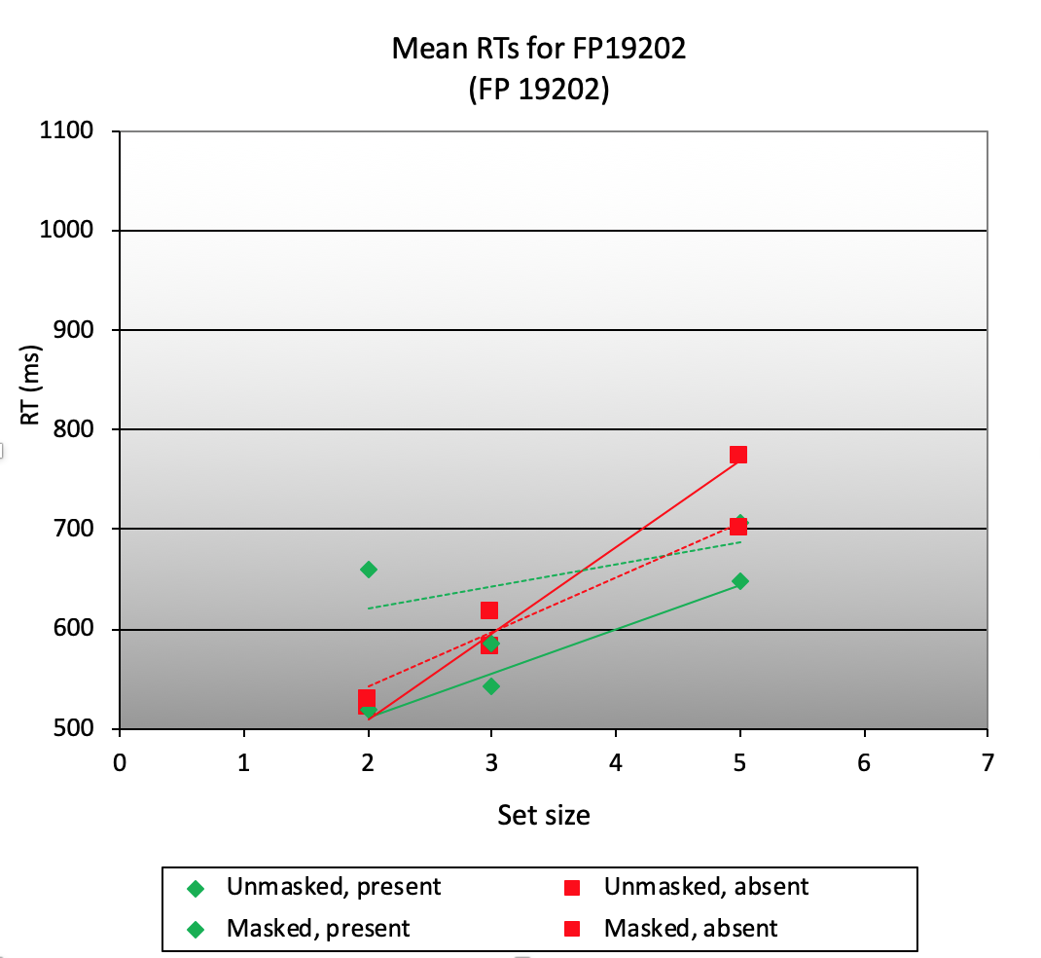

Figure 2: RT across masking and set size conditions for FP19202.

## Degraded stimuli are unmasked during encoding

Figure 3 displays RT across set size and masking, suggesting that masked conditions demand longer RTs. Further, the slopes resemble each other, whereas the zero-intercepts differ; if underlying effects are significant, that would be consistent with Sternberg’s (1969) idea of an “unmasking” during encoding.

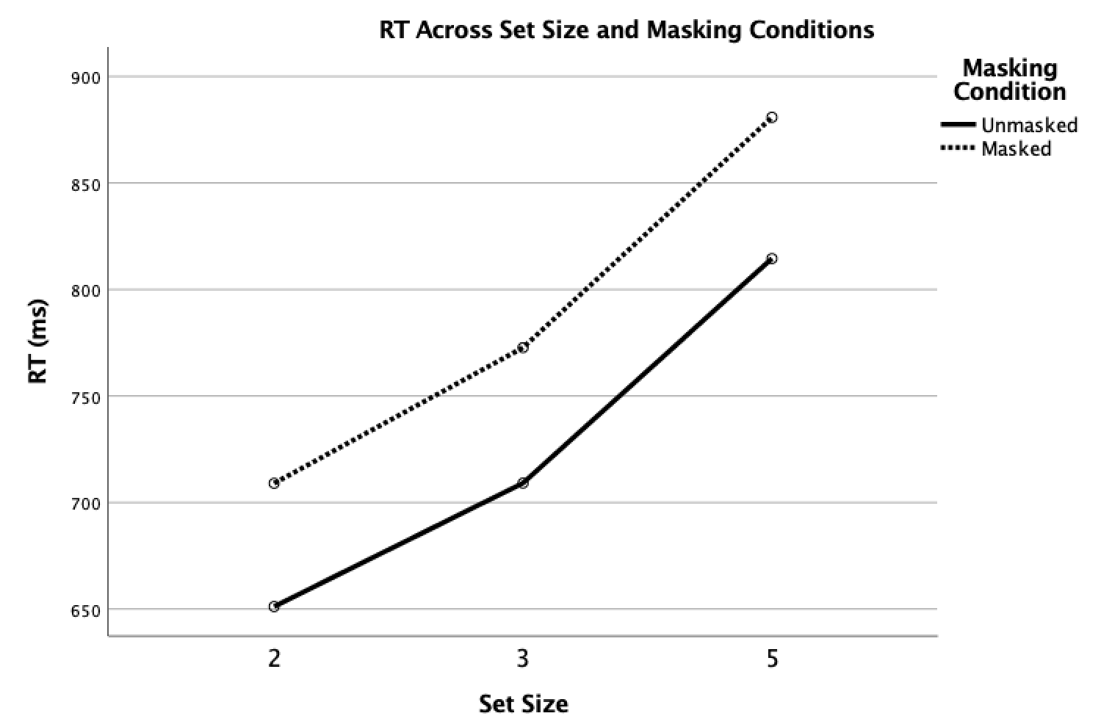

Figure 3: RT across masking and set size conditions suggest an unmasking during encoding.

A repeated measures ANOVA showed significant main effects of set size, *F*(1.38, 265.51) = 462.24, *p* < .001, $η_{p}^{2}$ = .71 (Huyhn-Feldt corrected), and masking, *F*(1, 193) = 273.39, *p* < .001, $η_{p}^{2}$ = .59, but no significant interaction between these, *F*(1.84, 354.66) = 0.55, *p* = .56, $η_{p}^{2}$ = .003 (Huyhn-Feldt corrected).

Thus, the perceived differences in RT (Figure 3) are significant. Equally, the influence of masking did not vary between set sizes, lending support for an “unmasking” during encoding.

To further investigate this, paired samples *t*-tests (two-tailed, $α$ = .05) were conducted, testing differences in zero-intercepts and slopes of corresponding fitted lines (Figure 3). These showed a significant difference between zero-intercepts, *t*(193) = -5.68, *p* < .001, *d* = 0.38, but no significant difference between slopes, *t*(193) = -0.89, *p* = .38, *d* = 0.07, consistent with Sternberg’s (1969) ideas of how an “unmasking” would appear graphically.

## Accuracy is better when the probe is absent

Figure 4 shows accuracy as a function of set size, masking, and test letter.

Figure 4: Accuracy for entire sample suggests that participants make fewer mistakes when the probe is absent.

A repeated measures ANOVA was conducted to test the influences of these variables on accuracy.

The test showed significant main effects of set size, *F*(2, 386) = 17.04, *p* < .001, $η_{p}^{2}$ = .08, masking, *F*(1, 193) = 9.25, *p* = .003, $η_{p}^{2}$ = .05, and test letter, *F*(1, 193) = 118.64, *p* < .001, $η_{p}^{2}$ = .38, and significant interactions between set size and masking, *F*(1.88, 363.26) = 6.64, *p* = .002, $η_{p}^{2}$ = .03 (Huyhn-Feldt corrected), between masking and test letter, *F*(1, 193) = 44.80, *p* < .001, $η_{p}^{2}$ = .19, and between set size, masking, and test letter, *F*(2, 386) = 7.27, *p* = .001, $η_{p}^{2}$ = .04, but no significant interaction between set size and test letter, *F*(2, 386) = 0.05, *p* = .95, $η_{p}^{2}$ = 0.00.

Thus, accuracy is influenced by all three variables. The interactions show that influence of set size varies between masking conditions, and influence of masking varies depending on test letter presence (see Figure 4). Further, accuracy was always best when the test letter was absent (Figure 4). The three-way interaction means that the combined influence of two factors varied depending on the third variable.

Figure 5 shows mean accuracy for FP19202. The general tendencies shown in Figure 4 do not appear present at an individual level, suggesting we should be careful not to exaggerate them.

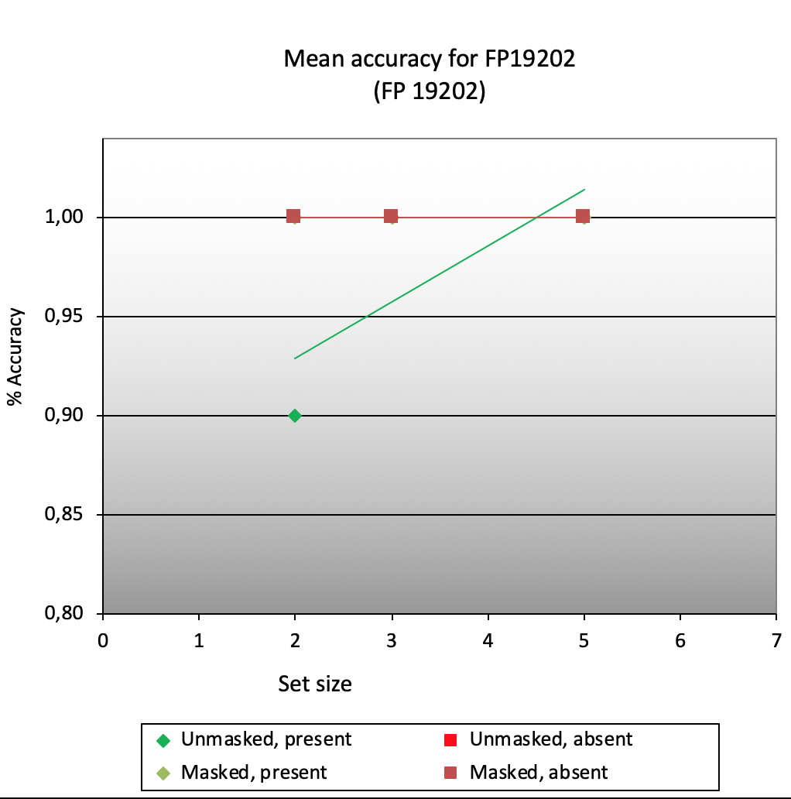

Figure 5: Mean accuracy across conditions for FP19202.

## No speed-accuracy trade-offs

Considering set sizes of five, Pearson’s correlations (two-tailed) showed no significant correlations between RT and accuracy when the test letter was masked and present, *r*(192) = .12, *p* = .09, masked and absent, *r*(192) = .08, *p* = .28, unmasked and present, *r*(192) = .10, *p* = .18, or unmasked and absent, *r*(192) = .01, *p* = .95. Thus, there is no evidence for any speed-accuracy trade-offs.

# Conclusion

Following Sternberg’s (1969) reasoning, the present experiment supports the claim that most people perform a serial self-terminating search in recognition tasks, and that degradation of test stimuli demands an initial “unmasking” prior to comparison.

# Literature

Radvansky, G. A. & Ashcraft, M. H. (2014). *Cognition*(6. udg.). Pearson Education.

Sternberg, S. (1969). Memory-scanning: mental processes revealed by reaction-time experi-

ments. *American Scientist*, *57*, 421-457.